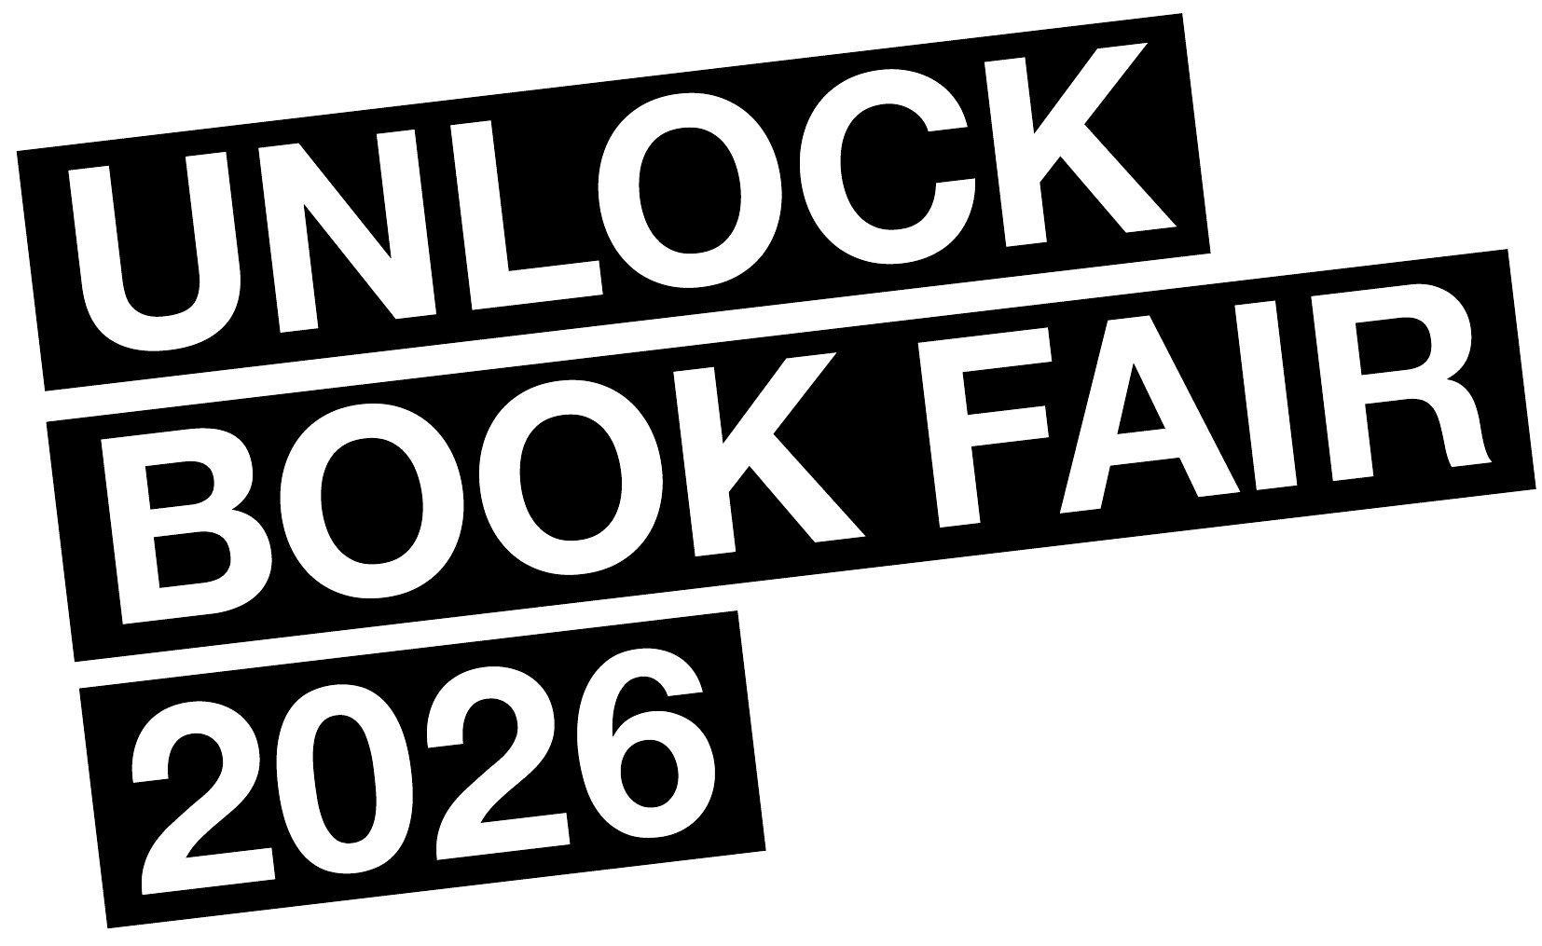
PRESS RELEASE
Unlock Book Fair 2026: The World of Graffiti and Street Art Books Comes to Völklinger Hütte
8–10 May 2026 | UNESCO World Heritage Völklinger Hütte
The Unlock Book Fair, the world’s leading event for graffiti and subcultural art publishing, celebrates its 10th anniversary at the UNESCO World Heritage Völklinger Hütte from 8 to 10 May. The fair takes place alongside the opening of the Urban Art Biennale, creating a unique cultural weekend at one of Europe’s most impressive heritage sites.
Over 80 publishers confirmed so far—coming from 22 countries across four continents—will present 800+ titles for direct purchase, most of them independent publications not available through conventional bookstores. The selection ranges from high-quality photography books and artist monographs to limited edition zines, with subject matters spanning graffiti, street art, and related subcultures including hip hop, punk, rave, and urban exploration.
Much more than a book fair
The weekend features over 50 programme events, including talks by international speakers, book launches, panel discussions, rare film screenings, guided tours, a live dance performance, and a children’s workshop. Highlights include an artist residency by Parisian artists Tomek and Mosa (PAL Crew), who will create calligraphic interventions across the streets of Völklingen, and a talk by the director of the Museum of Graffiti in Miami, the world’s first museum dedicated to graffiti as an art form.
A film programme curated by WissensART Foundation brings rare documentaries about street art pioneers to Kino Achteinhalb in Saarbrücken (Friday evening, free access) and to the Völklinger Hütte stage on Saturday, accompanied by a panel on street art and monument protection. Berlin choreographer Kadir ‘Amigo’ Memis closes Saturday with a dance and live music performance.
10th anniversary at the Völklinger Hütte
Founded in Barcelona in 2016, the Unlock Book Fair has travelled to cities including Berlin, Amsterdam, Cologne, Hamburg, and Munich, growing into the essential annual gathering for the international graffiti publishing community. This 10th anniversary edition marks the most ambitious programme to date.
The fair is presented by GRACE Project (Greater Region Artistic and Cultural Education), an Interreg initiative connecting 25 cultural operators, local governments, and universities across Belgium, France, Germany, and Luxembourg.
Since its launch in 2011, the URBAN ART BIENNALE has featured nearly 400 artists and drawn over 500,000 visitors to the Völklinger Hütte. This year’s edition presents 50+ artists from around the world.

Practical information
Unlock Book Fair 2026
8–10 May
Völklinger Hütte
Rathausstraße 75–79
66333 Völklingen
Friday 8 May: 1:00–6:30pm
Saturday 9 May: 11:00am–7:00pm
Sunday 10 May: 11:00am–5:00pm
Tickets: Day €17 | Three-day €27 (Unlock discount)
Includes URBAN ART BIENNALE + X-RAY exhibition

URBAN ART CINEMA
Friday 8 May, 7:30pm, Kino Achteinhalb, Nauwieserstraße 19, Saarbrücken, Free access
Saturday 9 May: 1:00pm, Ore shed Völklinger Hütte, from 4:30pm access is free

URBAN ART BIENNALE Opening:
Saturday 9 May: 4:30–10:00pm, World Heritage Site Völklinger Hütte
Free access

Independent publishers can apply for a free table until 3 April at unlockfair.com.
Presented by GRACE Project, Unlock Bureau, Urban Art Biennale
With support from World Heritage Site Völklinger Hütte, WissensART Foundation, Le Grand Jeu

Press contact
Javier Abarca
Director, Unlock Bureau
javier@unlockfair.com | +34 645 531 200
unlockfair.com

